Scenario 1: All Register Participant Modals

1. Log in as Case Worker.
2. Go to Cases and Outcomes tab.
3. Open Shortcuts – Registration
4. Try all the Register options links in this section
   1. Register Person
   2. Register Prospect Person
   3. Register Employer
   4. Register Prospect Employer
   5. Register Educational Institute
   6. Register External Party
   7. Register Information Provider
   8. Register Utility
   9. Register Product Provider
   10. Register Service supplier

Verify that at top of fields in any Address Cluster (Private Address, Mailing Address, Registered Address, Business Address, Address) the text **At least Apt/Suite or Street 1 must be entered** is present and when Navigated to the fields the Screen reader reads that message along with the Label for that field

And also when caseworker tries to edit the corresponding Address for the Participant (ex: Registered/Business Address for Employer etc.)

This is example where we have Address with-out cluster

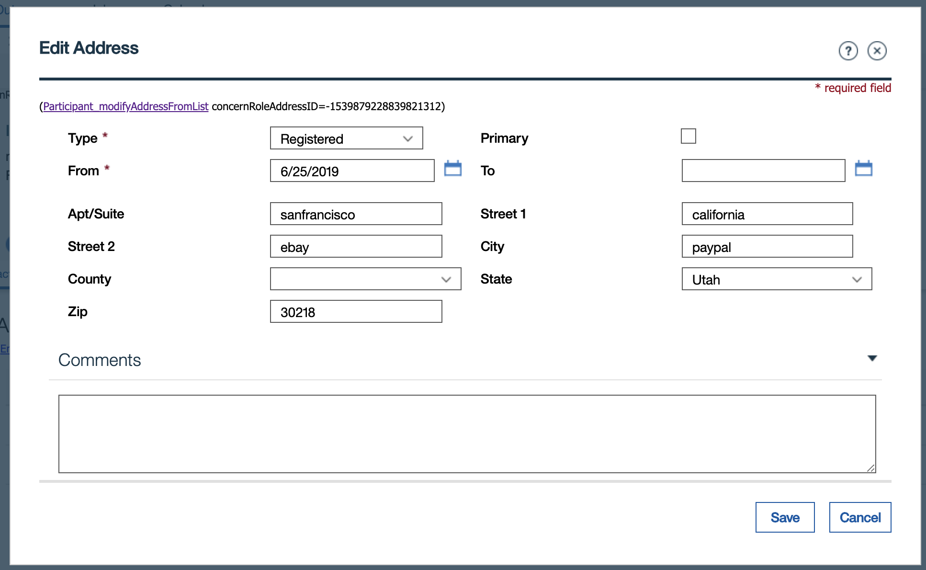

Verify that at top of fields in any Address Cluster (Private Address, Mailing Address) or with-out Cluster( Registered Address, Business Address, Address) the text **At least Apt/Suite or Street 1 must be entered** is present and when Navigated to the fields the Screen reader reads that message along with the Label for that field

For External Party, there is something called Office Address check that on Edit we get the same message

Try this for all Participants (Employer, Utility, External Party, Educational Institute, Information Provider, Product Provider, Service Supplier)

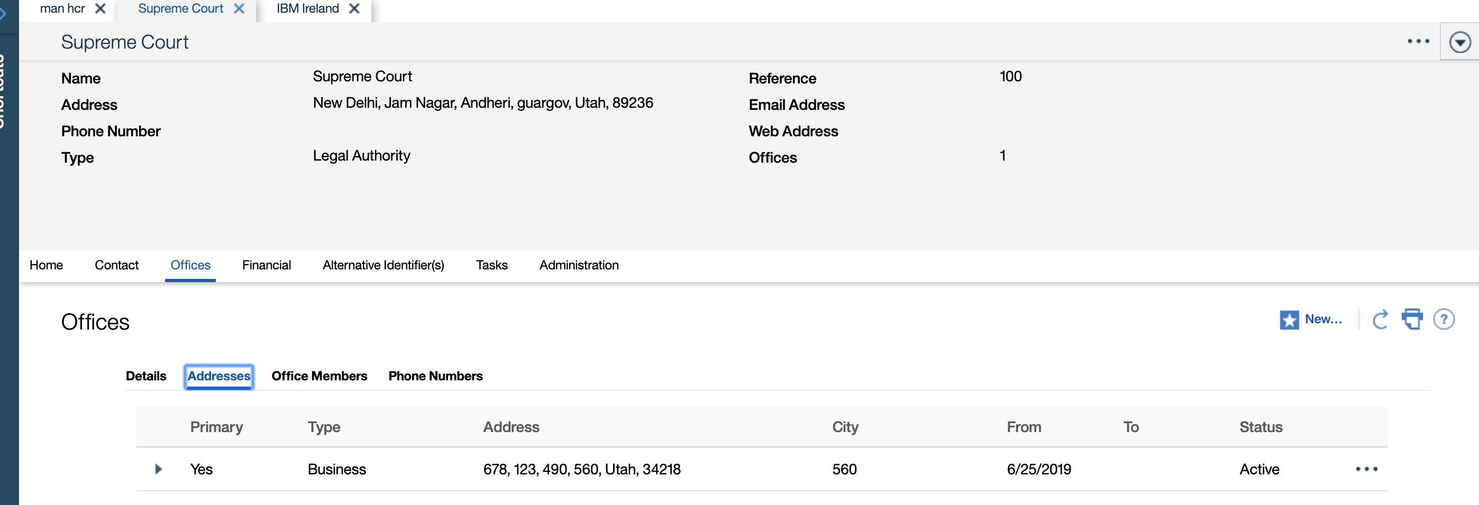

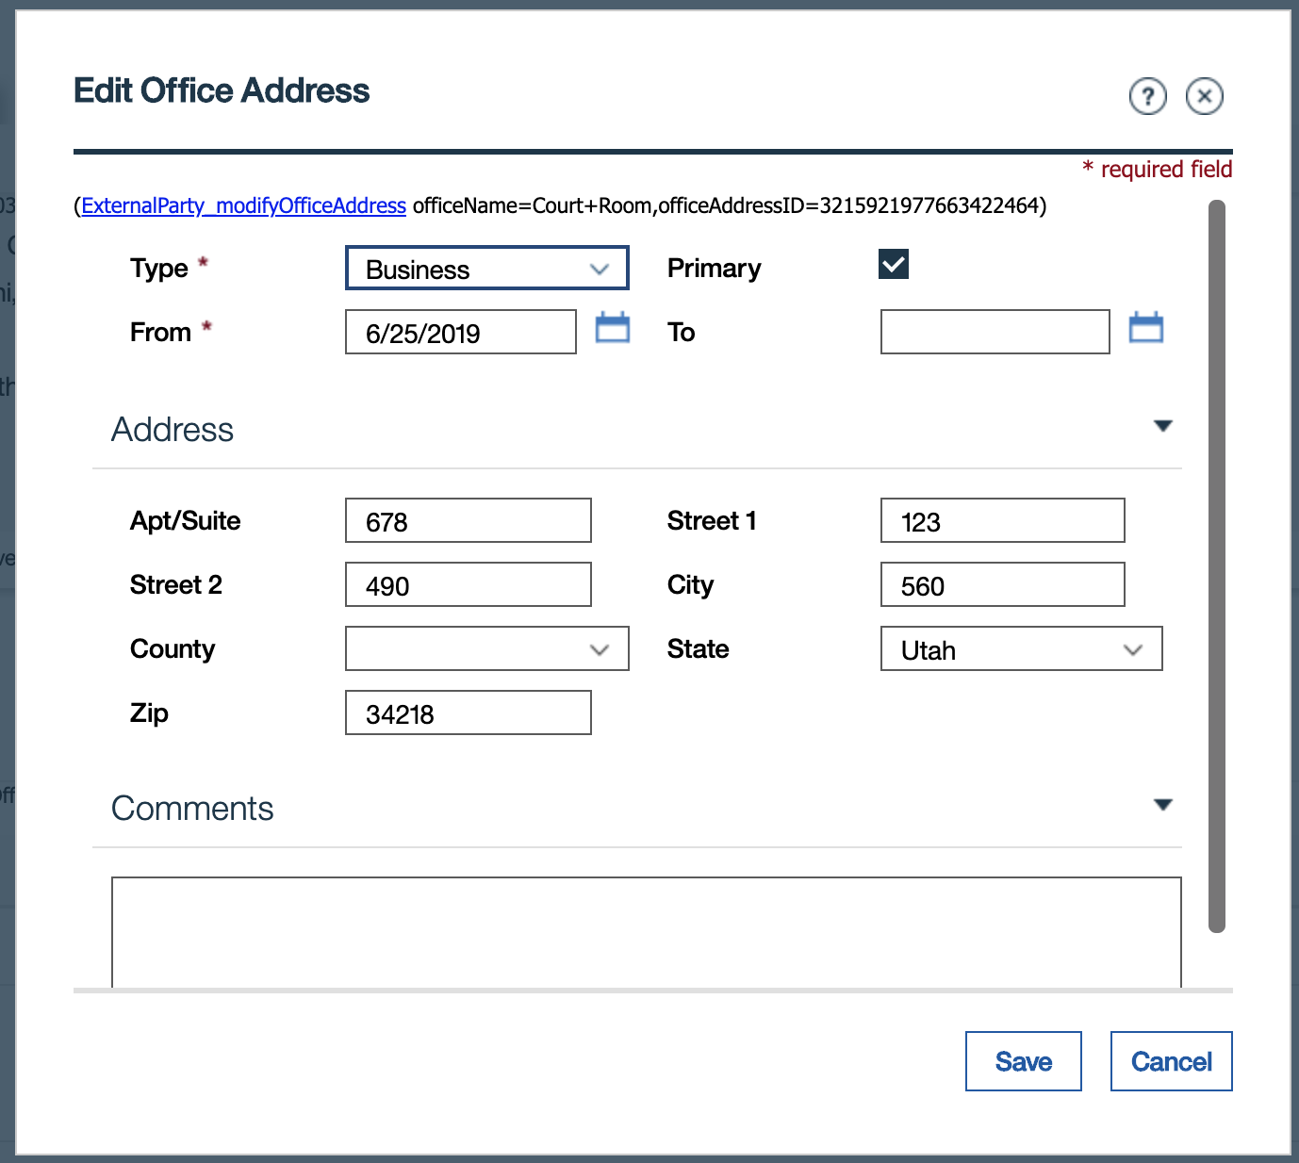

Also New Address from same Screen by clicking on New link in Contact tab for all other Participants except Person & Prospect Person

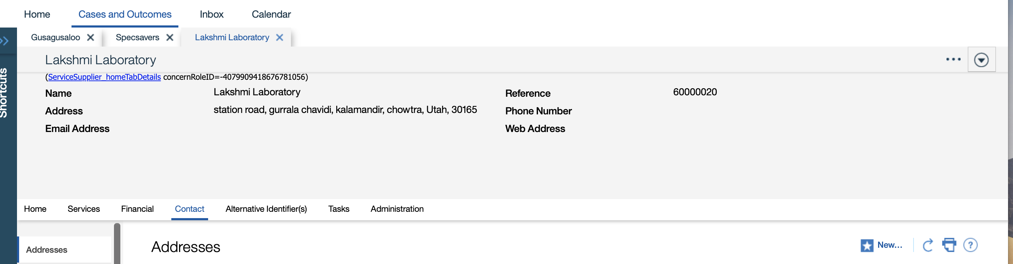

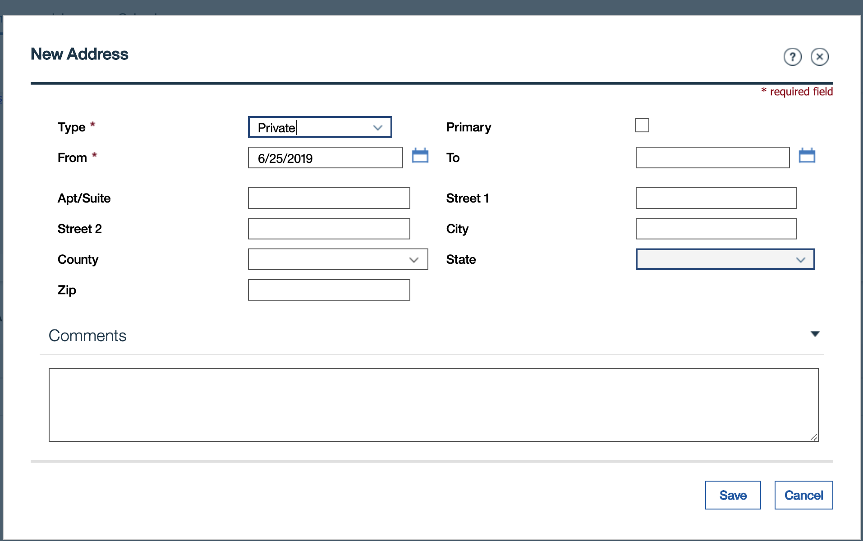

Scenario 2: Modals where you create Case & Register Person together

1. Log in as Case Worker.
2. Go to Cases and Outcomes tab.
3. Open Shortcuts – Cases
4. Try the following 2 options links in this section
   1. Register Person and Create Case
   2. Add Prospect Person and Create Case

Verify that at top of fields in the Address Cluster (Private Address, Mailing Address) the text **At least Apt/Suite or Street 1 must be entered** present and when Navigated to the fields the Screen reader reads that message along with the Label for that field

Scenario 3: Modals where you try to Register Prospect Person as Person

1. Login as ccsinvestigator/ccssdminvestigator
2. Create an Investigation for Approved Intake.
3. Try to Register the Participants on the Investigation case.

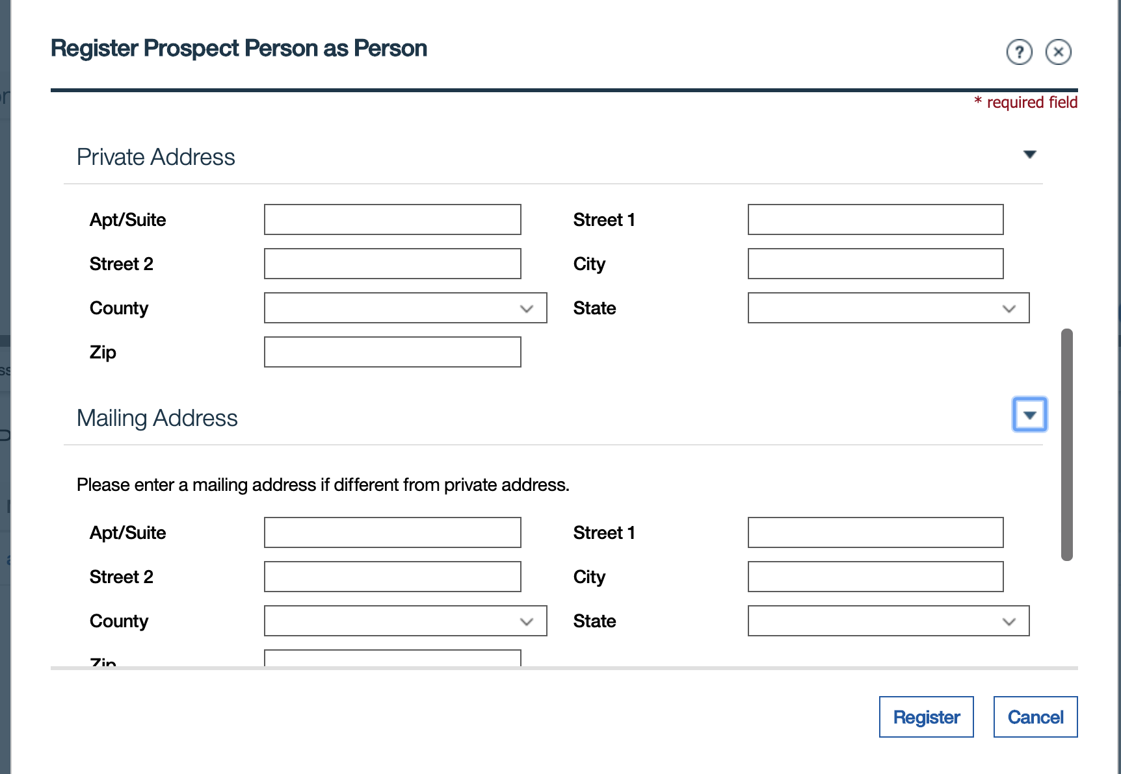

Verify that at top of fields in the Address Cluster (Private Address, Mailing Address) the text **At least Apt/Suite or Street 1 must be entered** present and when Navigated to the fields the Screen reader reads that message along with the Label for that field

Scenario 4: Address cluster in Guided Wizard

In Guided Wizard on Insurance Affordability AC/IC OR Income Support AC/IC for the question **Does the person live with someone in the household ?** answer NO



Verify that at top of fields in the Address Cluster the text **At least Apt/Suite or Street 1 must be entered** present and when Navigated to the fields the Screen reader reads that message along with the Label for that field

Scenario 5: Modal for Adding/Editing Address for a Person from PDC (person tab) or from an Application Case (AC) or Integrated Case

On PDC (person tab) for Adding /Editing Address

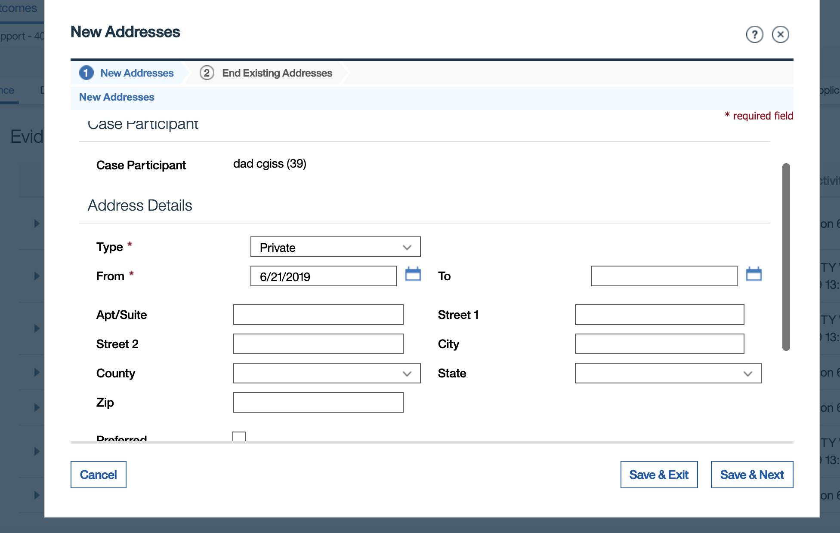

Verify that at top of fields in the Address Details cluster the text **At least Apt/Suite or Street 1 must be entered** present and when Navigated to the fields the Screen reader reads that message along with the Label for that field

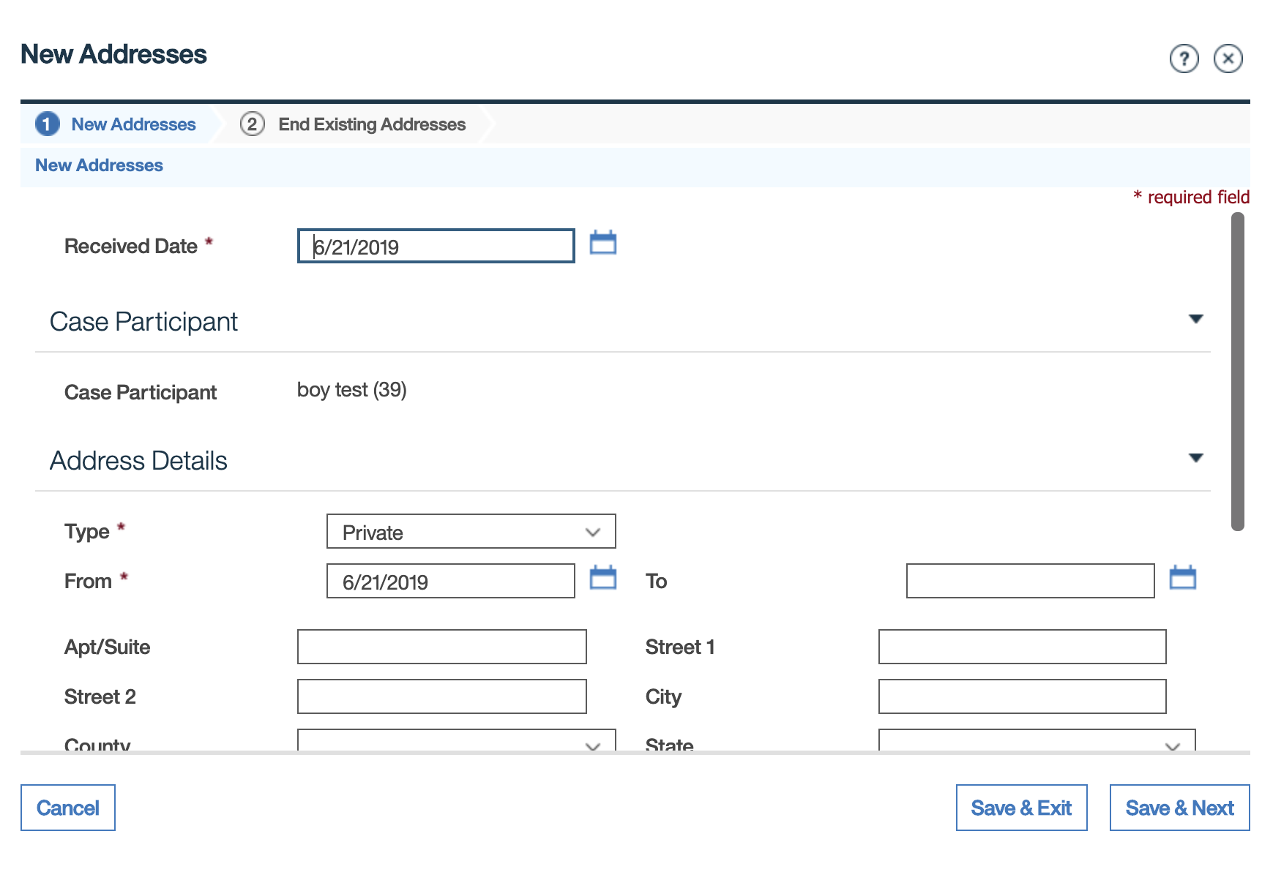

Same modal present when adding/editing on Income Support AC/IC OR Insurance Affordability AC/IC

Scenario 6: Modals for creating Inbound/Outbound Agreement in Ongoing Case

1. Login as ccscaseworker
2. Register a child (ex: 12 years) & create an Ongoing case.
3. On Ongoing case open Legal tab and then Inter-Jurisdiction
4. Click on Create Inbound or Outbound Agreement to open the corresponding Widget

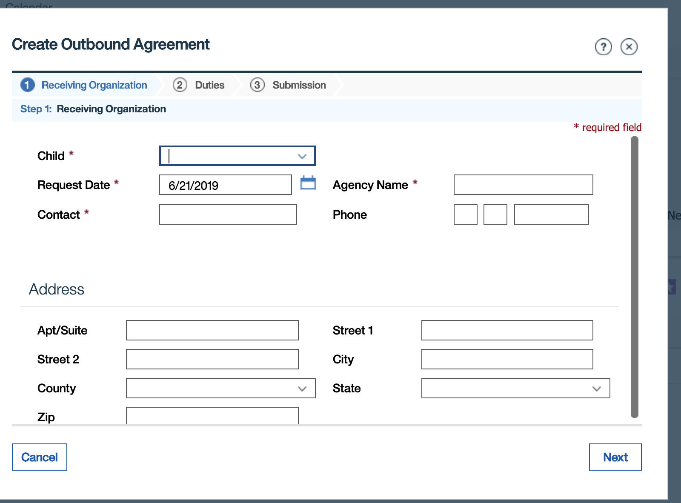

Verify that at top of fields in the Address Details section the text **At least Apt/Suite or Street 1 must be entered** present and when Navigated to the fields the Screen reader reads that message along with the Label for that field

Scenario 7: Modals for creating New Case Nominee or Change Nominee Address

1. Login as superuser
2. Register a person & create an Social Assistance case.
3. Add Employment evidence, Apply changes & create an Employment Benefit Case
4. Go to Financials Tab -> Nominee in Employment Benefit PD and click on New to open New Case Nominee modal

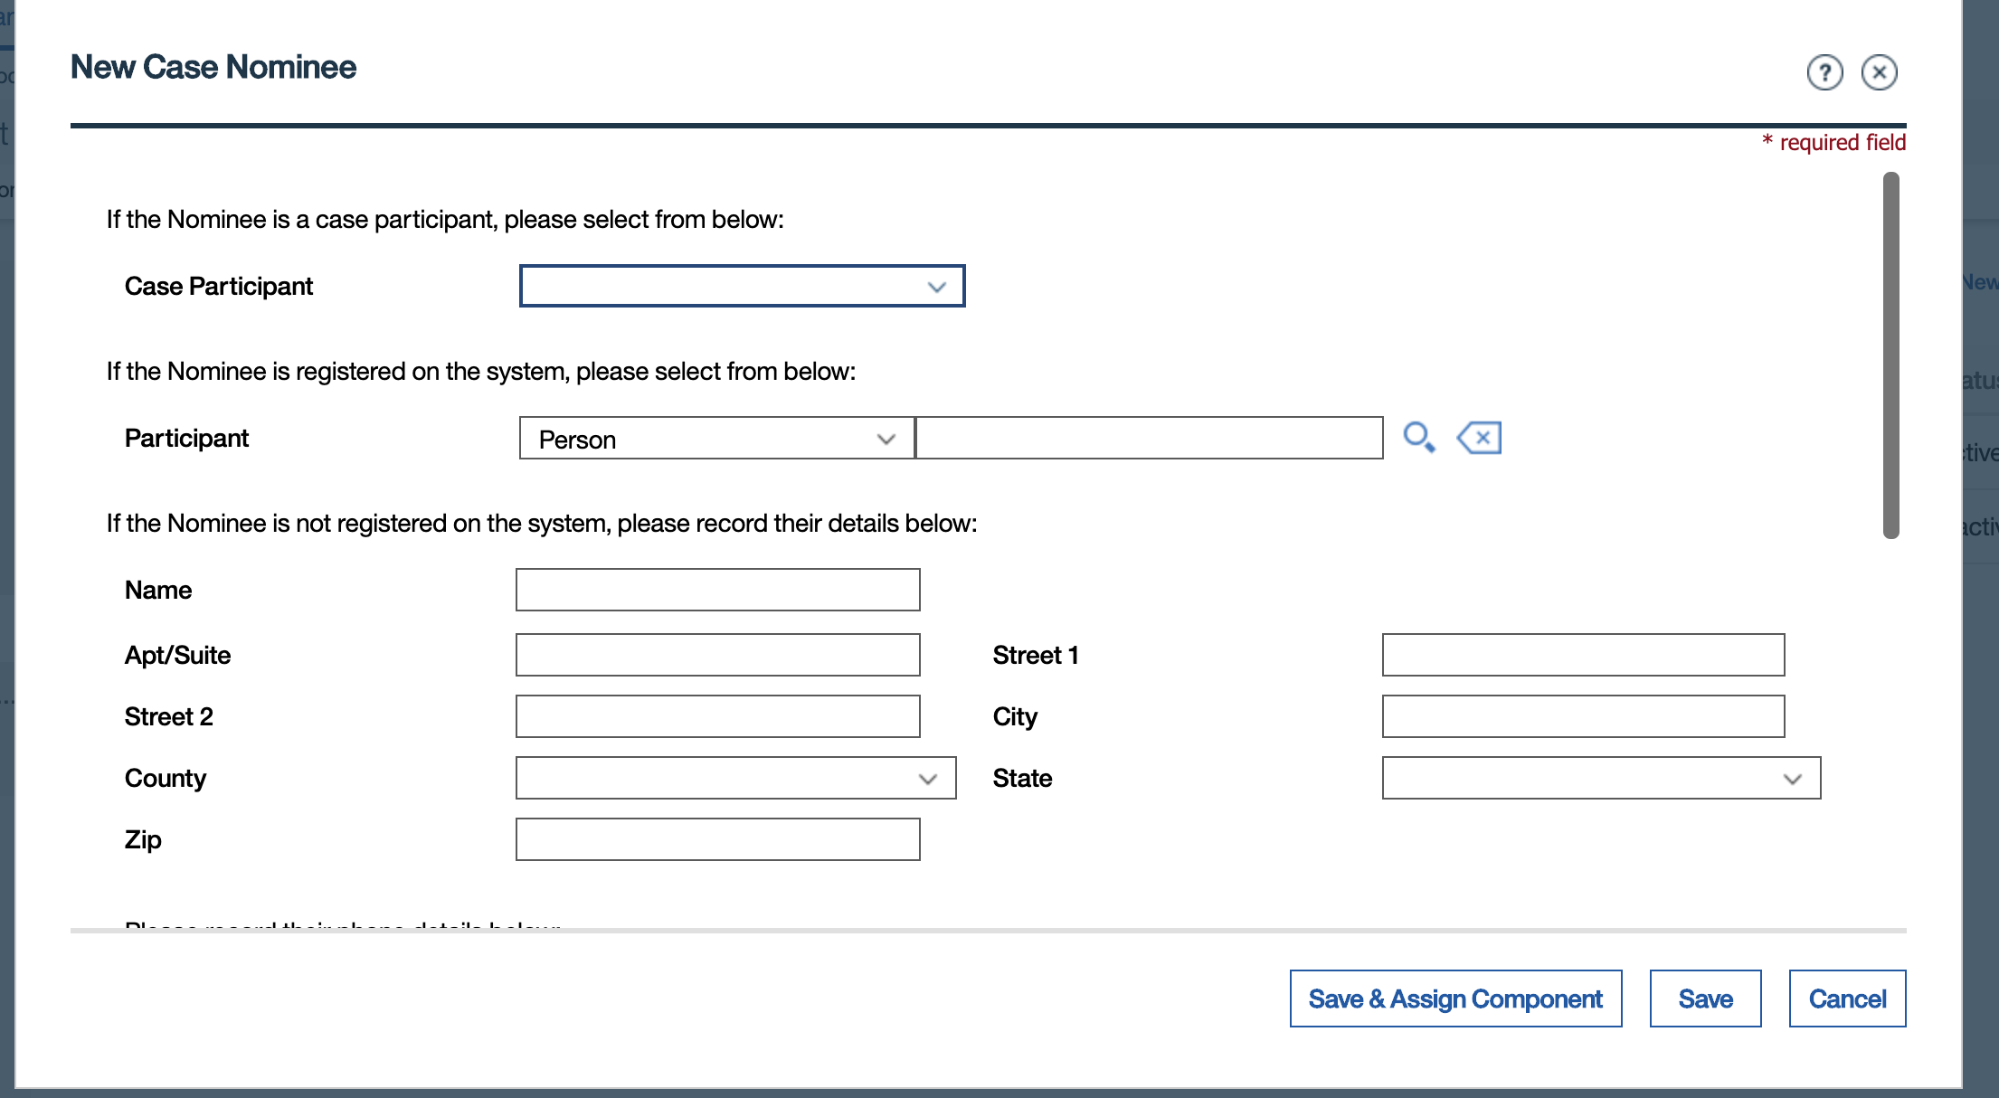

To open Change Nominee Address, Open Actions menu next to a Nominee and click on Change Address option to open Change Nominee Address Modal

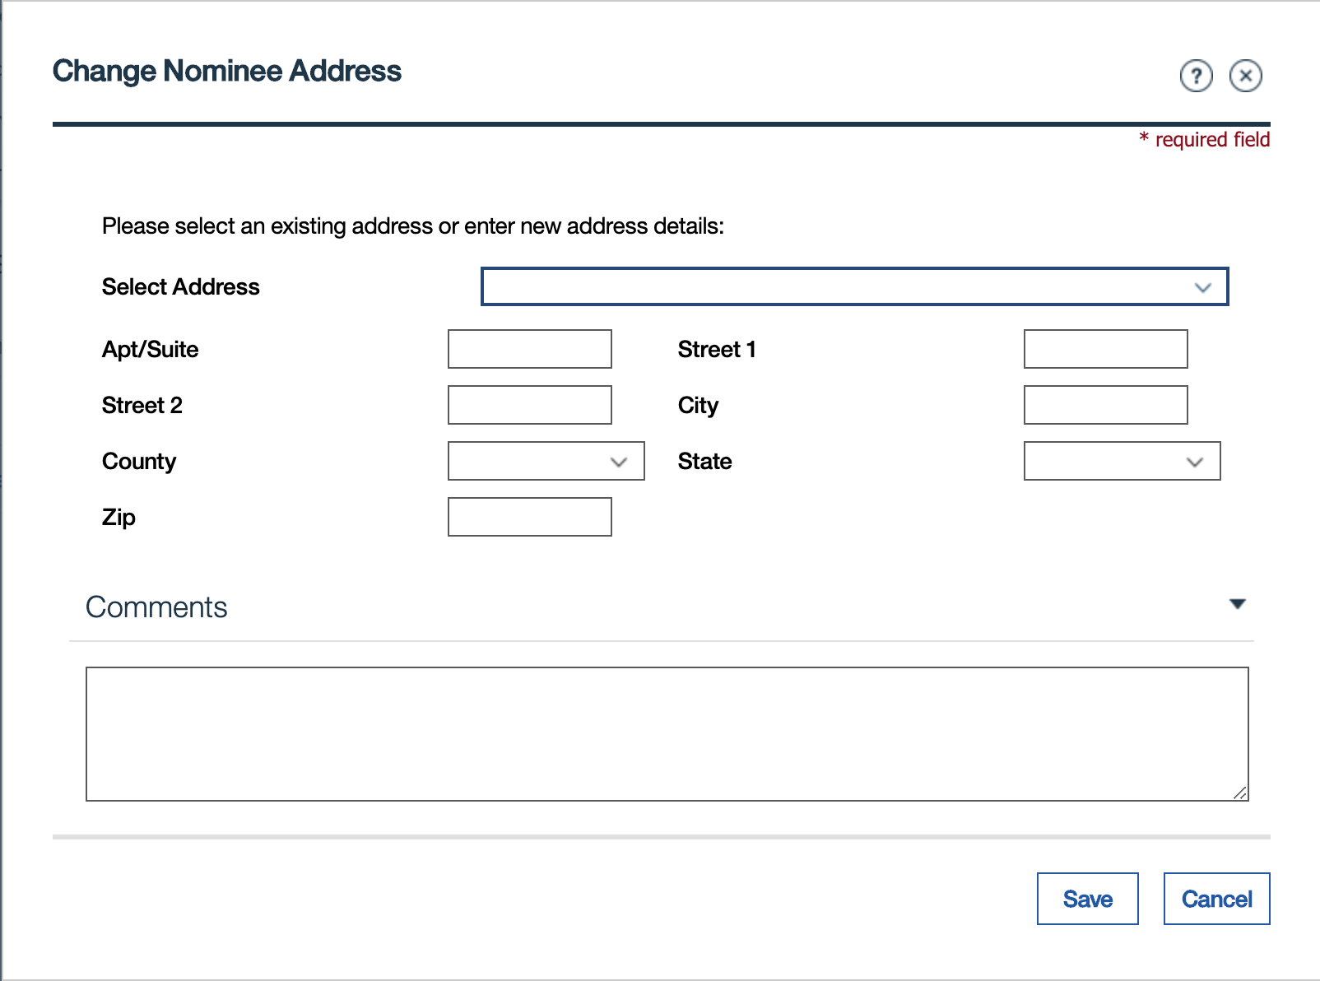

Verify that in both modals at top of fields in the Address section the text **At least Apt/Suite or Street 1 must be entered** present and when Navigated to the fields the Screen reader reads that message along with the Label for that field